IBM Project
Report
On
Proactive Equipment Care using Analytics with Cloud - Cloud Integrated Analytics

Developed By: - | Guided By:-
Patel Megh (22162121011) | Prof. Umesh Lakhtariya (Internal)
Pratham Prajapati (22162171023) | Mr. Anoj Dixit (External)
Patel Tirth (22162101016)

Submitted to
Faculty of Engineering and Technology
Institute of Computer Technology
Ganpat University



Year - 2026

ABSTRACT

Proactive Equipment Care using Analytics with Cloud – Cloud Integrated Analytics focuses on designing a smart, data-driven system that continuously monitors equipment health to prevent failures before they occur. The proposed solution leverages cloud computing to collect, store, and process real-time and historical data from equipment sensors and operational logs. Advanced analytics and machine learning techniques are applied to identify performance patterns, detect anomalies, and predict potential breakdowns at an early stage. By integrating analytics with cloud infrastructure, the system ensures scalability, high availability, and remote accessibility while reducing on-premise maintenance costs. This approach enables timely maintenance decisions, minimizes unplanned downtime, extends equipment lifespan, and improves overall operational efficiency, making it a reliable and cost-effective solution for modern industrial environments.

Index
Title | Page No
CHAPTER 1: INTRODUCTION | 5
CHAPTER 2: PROJECT SCOPE | 6
CHAPTER 3: SOFTWARE AND HARDWARE REQUIREMENTS | 7
3.1 Minimum Software Requirements | 7
3.2 Minimum Hardware Requirements | 7-8
CHAPTER 4: PROCESS MODEL | 8
4.1 Model Overview | 8
4.2 Data Preparation | 9
4.3 LSTM Model Architecture | 11
4.4 Model Training | 11
4.5 Model Evaluation | 12
4.6 Prediction Process | 13
4.7 Model Deployment | 14
4.8 Model Maintainence | 14
4.9 Limitations & Assumptions | 15
4.10 Expected Outcomes | 15
CHAPTER 5: PROJECT PLAN | 16
5.1 List Of Major Activities | 16
5.2 Estimated Time Durations | 18
CHAPTER 6: IMPLEMENTATION DETAILS | 19
6.1 Project Execution Workflow | 19
6.1.1 Sequential Execution Steps | 19
6.2 Risk Management | 21
6.2.1 Technical Risks | 21
6.2.2 Operational Risks | 21
6.3 Success Criteria | 21
6.3.1 Technical Metrics | 21
6.3.2 System Performance Metrics | 22
6.3.3 Business Metrics | 22
6.4 Functional Requirements | 23
6.4.1 Core System Capabilities | 23
6.5 Coding Explaination | 23-30
CHAPTER 7: CONCLUSION | 31
CHAPTER 8: REFRENCES

CHAPTER 1: INTRODUCTION

Organizations require their equipment to operate continuously because equipment downtime creates safety risks and prevents businesses from achieving their productivity needs and operational targets. Equipment failures disrupt operations while creating financial losses and raising maintenance expenses and decreasing customer satisfaction. Reactive maintenance has served as the primary maintenance method for industries because it involves conducting repairs after machines reach their breakdown point. This method generates unexpected operational stops which lead to expensive urgent maintenance work. Preventive maintenance requires equipment to follow its scheduled maintenance times, but this method does not evaluate actual equipment conditions, which results in both excessive maintenance activities and failure detection problems.

Digital technologies have developed rapidly, which has created new chances for intelligent maintenance systems through access to vast equipment and sensor data streams. Organizations use analytics and data-driven decision-making to transition from time-based maintenance approaches toward condition-based and predictive maintenance systems. Organizations can monitor their operational systems through nonstop surveillance of key parameters, which include temperature, vibration, pressure, and usage patterns, to identify system abnormalities and performance drops and to predict future equipment failures. Organizations use this proactive approach to create optimized maintenance plans, which help them achieve less operational downtime and increased durability for their essential resources.

The IBM project named "Proactive Equipment Care using Analytics with Cloud - Cloud-Integrated Analytics" intends to use modern technology through its system, which combines analytics functions with cloud computing resources. The project focuses on collecting real-time and historical equipment data and securing its storage into two separate data systems.

CHAPTER 2: PROJECT SCOPE

The scope of the IBM project titled “Proactive Equipment Care using Analytics with Cloud – Cloud-Integrated Analytics” is to design and develop a cloud-based analytical system that enables proactive monitoring and maintenance of equipment using data-driven techniques. The project focuses on collecting, storing, and analyzing historical as well as real-time equipment data to gain meaningful insights into equipment performance and health. By leveraging cloud infrastructure, the system ensures scalability, reliability, and secure data management while supporting remote access and centralized monitoring.

This project includes the development of a backend system using Python and Flask to handle data ingestion, processing, and communication between different system components. A cloud database and storage solution are used to manage structured and unstructured equipment data efficiently, while authentication mechanisms ensure secure user access. Data preprocessing and exploratory analysis are carried out using analytical tools to clean and prepare the data for modeling. Machine learning models are developed to predict potential equipment failures, detect anomalies, and support condition-based maintenance strategies.

The project scope also covers the creation of interactive dashboards and visualizations to present analytical results, performance trends, and predictive insights in an understandable manner for end users. These visualizations help maintenance teams and decision-makers take timely and informed actions. However, the scope of this project is limited to analytical prediction and monitoring; it does not include physical sensor installation, real-time hardware control, or automated maintenance execution. Overall, the project aims to demonstrate how cloud-integrated analytics can transform traditional maintenance approaches into a proactive, efficient, and cost-effective equipment care solution.

CHAPTER 3: SOFTWARE AND HARDWARE REQUIREMENTS

- 3.1 Minimum Software Requirements

Category | Software/Tools
Operating System | Windows / Linux / macOS
Programming Language | Python 3.9+
Editor | VS Code
Data Processing | Jupyter Notebook
Machine Learning | Machine Learning
Backend Framework | Flask
Cloud Storage | Supabase Storage
Database | Supabase PostgreSQL
Authentication | Supabase Auth
Visualization | Tableau Public
Frontend | HTML, CSS, JavaScript
Version Control | Git (Optional)

- 3.2 Minimum Hardware Requirements

Component | Specification
Processor | Intel i5 / AMD Ryzen 5 or higher
RAM | Minimum 8 GB (16 GB recommended)
Storage | 50 GB free disk space
Internet | Stable broadband connection
Motor Data | Simulated CSV files representing motor parameters

CHAPTER 4: PROCESS MODEL

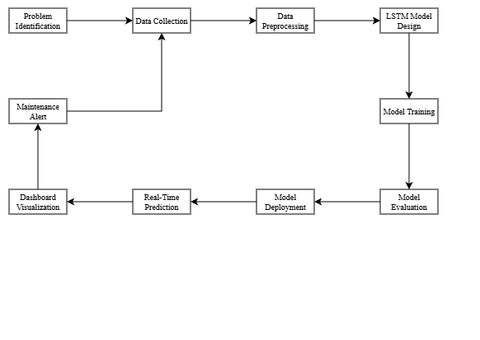

- 4.1 Model Overview
- Model Inforamtion
- Model Name: Motor Failure Prediction LSTM Model
- Model Type: Long Short-Term Memory (LSTM) Neural Network
- Framework: TensorFlow/Keras
- File Location: models/motor_lstm_model.h5
- Purpose: Predict equipment failure probability for proactive maintenance

- Problem Statement
- Develop a deep learning model to predict motor equipment failure probability based on historical sensor data, enabling maintenance teams to schedule proactive maintenance 24-48 hours before potential failures, thereby reducing unplanned downtime and maintenance costs.

- Why LSTM?
- Excels at learning temporal patterns in time-series sensor data
- Captures long-term dependencies through memory mechanism
- Handles sequential data better than traditional ML algorithms
- Suitable for continuous monitoring applications

- 4.2 Data Preparation
- Input Features (Sensor Readings):
- Temperature (°C) - Motor and bearing temperature
- Vibration (mm/s) - Multi-axis vibration measurements
- Current (Amperes) - Phase currents
- Voltage (Volts) - Line voltage
- RPM - Motor rotational speed
- Load (%) - Motor load percentage

- Target Variable:
- Binary Classification: Failure (1) or Normal (0)
- Prediction Window: 24-48 hours advance warning
- Data Preprocessing Pipeline:
- Step 1: Data Loading (Notebook 01)
Read CSV files from Supabase storage
Merge multiple datasets by timestamp and motor_id
Sort chronologically

- Step 2: Data Cleaning (Notebook 02)
Handle missing values (forward fill, interpolation)
Remove outliers using Z-score and IQR methods
Apply noise reduction filters
Normalize features using Min-Max Scaling (0-1 range)

- Step 3: Feature Engineering (Notebook 03)
Select 6-8 primary features
Create derived features (temperature rate of change, vibration trends)
Perform correlation analysis to remove redundancy
Define target variable (failure within 48 hours = 1)

- Step 4: Sequence Creation (Notebook 04)
Create time-series sequences using sliding window
Sequence Length: 30 time steps (30 minutes of data)
Input Shape: (samples, 30, 8) - 30 timestamps, 8 features
Output Shape: (samples, 1) - Failure probability
Data Split: 70% Training, 15% Validation, 15% Test

- 4.3 LSTM MODEL ARCHITECTURE
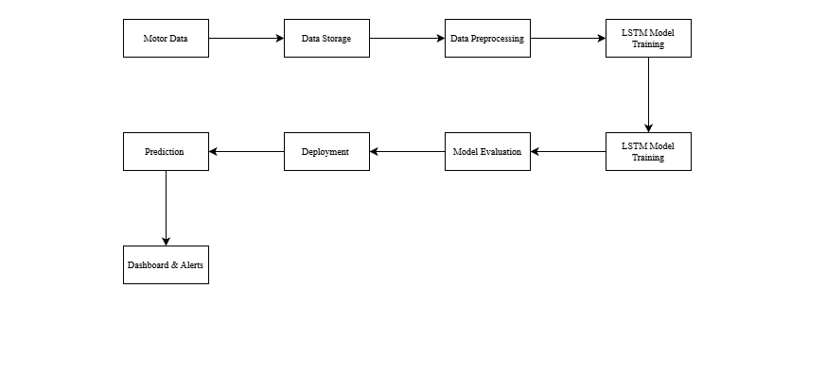

- Model Compilation
- Optimizer: Adam (learning rate = 0.001)
- Loss Function: Binary Crossentropy
- Metrics: Accuracy, Precision, Recall, F1-Score, AUC-ROC

- 4.4 MODEL TRAINING
- Training Configuration
- Epochs: 50-100 (with early stopping)
- Batch Size: 32
- Validation Split: 15%

- Callbacks
- Early Stopping: Stop if validation loss doesn't improve for 10 epochs
- Model Checkpoint: Save best model based on validation loss

- Handling Class Imbalance
- Class Weights: Higher weight for failure class (rare events)
- SMOTE: Synthetic oversampling of minority class
- Threshold Adjustment: Lower threshold (0.3-0.4) to favor recall

- Training Process
- Forward propagation through LSTM layers
- Calculate binary crossentropy loss
- Backpropagation through time (BPTT)
- Update weights using Adam optimizer
- Validate on validation set after each epoch
- Save best model and stop if no improvement

- 4.5 MODEL EVALUATION
- Performance Metrics & Targets
- Recall (Sensitivity): > 90% - CRITICAL (minimize missed failures)
- Precision: > 75% - Minimize false alarms
- F1-Score: > 0.80 - Balance between precision and recall
- Accuracy: > 85% - Overall correctness
- AUC-ROC: > 0.90 - Threshold-independent performance

- Confusion Matrix
 | Predicted Normal | Predicted Failure
Actual Normal | TN | FP
Actual Failure | FN | TP

- Where:
TP (True Positive): Correctly predicted failures - SUCCESS
FN (False Negative): Missed failures - CRITICAL TO MINIMIZE
FP (False Positive): False alarms - ACCEPTABLE
TN (True Negative): Correctly predicted normal operation

- 4.6 PREDICTION PROCESS
- Inference Pipeline (predict_and_export.py)
- Load trained model
- Prepare input data
- Generate prediction
- Risk classification
- Export results

- Prediction Frequency
- Batch Mode: Hourly/daily scheduled predictions
- Real-Time Mode: Continuous prediction for critical equipment

- 4.7 MODEL DEPLOYMENT
- Deployment Workflow
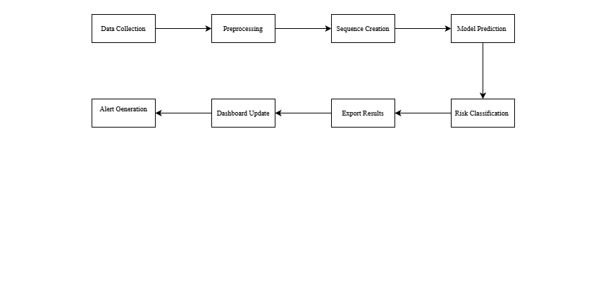

- Deployment Architecture
- Prediction Service (predict_and_export.py)
- Scheduling System
- Dashboard Integration
- Alert System

- 4.8 MODEL MAINTENANCE
- Continuous Improvement
- Monitor actual failures vs predictions
- Collect feedback from maintenance team
- Update training data with new failure examples
- Retrain model quarterly or when performance degrades
- Validate and deploy updated model

- Retraining Triggers
- Scheduled: Every 3 months
- Performance-based: Recall < 85% or Precision < 70%
- Data-based: New failure modes or equipment changes

- 4.9 LIMITATIONS & ASSUMPTIONS
- Limitations
- Requires high-quality historical failure data
- Prediction window limited to 24-48 hours
- Cannot predict sudden catastrophic failures
- Model specific to motor types used in training
- Deep learning "black box" - limited interpretability

- Assumptions
- Sensors are calibrated and functioning correctly
- Future failures follow similar patterns as historical data
- Equipment degradation is gradual and detectable
- Operating conditions remain within normal parameters

- 4.10 EXPECTED OUTCOMES
- Technical Outcomes
- Model accuracy > 85% on test dataset
- Recall > 90% for failure detection
- Early failure detection 24-48 hours in advance
- Automated prediction pipeline

- Business Outcomes
- 30% reduction in unplanned equipment downtime
- Improved maintenance scheduling efficiency

CHAPTER 5: PROJECT PLAN

- 5.1 List of Major Activities
- Project Initialization & Environment Setup
- Install required software (Python, VS Code, Jupyter, Tableau)
- Create project directory structure
- Initialize Git repository
- Configure development environment

- Cloud Infrastructure & Database Setup
- Create and configure Supabase project
- Set up storage bucket for raw motor data
- Design database tables (login_logs, model_predictions)
- Configure security policies and environment variables

- Data Pipeline Development
- Develop Supabase connection module
- Implement automated data download script
- Perform data validation and integrity checks
- Test end-to-end cloud-to-local data flow

- Data Preprocessing & Feature Engineering
- Load and merge raw sensor datasets
- Handle missing values and outliers
- Normalize and clean data
- Perform feature selection and correlation analysis

- LSTM Model Development & Training
- Prepare time-series sequences using sliding window
- Design multi-layer LSTM architecture
- Train and validate model
- Evaluate performance (Accuracy, Precision, Recall, F1, ROC-AUC)
- Save trained model

- Web Application & Authentication Development
- Develop login and dashboard UI
- Implement authentication using Supabase
- Develop Flask API backend

- Logging & Monitoring
- Implement login activity logging
- Store logs in Supabase database

- Documentation & Project Closure
- Prepare system architecture documentation
- Create user manual and installation guide

- 5.2 Estimated Time Durations

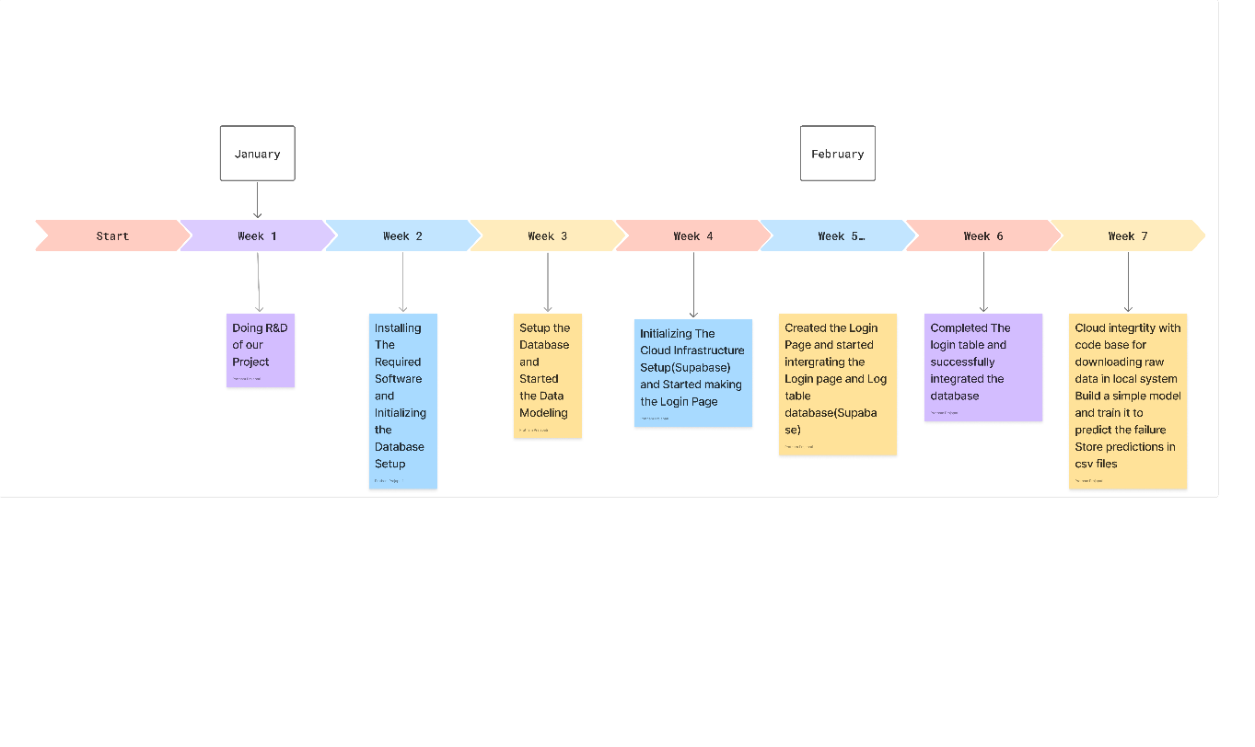

CHAPTER 6: IMPLEMENTATION DETAILS

- Project Execution Workflow
- Sequential Execution Steps
- Step 1: Install Dependencies like Pandas, NumPy ,TensorFlow/Keras, Supabase client, Flask, Scikit-learn

- Step 2: Configure Environment Variables Required Variables:
- SUPABASE_URL: Your Supabase project URL
- SUPABASE_KEY: Your Supabase anon/service key
- SUPABASE_BUCKET: Storage bucket name (motor-raw-data)

- Step 3: Create Database Tables
Action: Create Supabase database tables using provided SQL scripts
Tables to Create:
a) login_logs table: id (uuid, primary key), user_email (text),login_time (timestamp), ip_address (text), dashboard_accessed (text)

b) model_predictions table: timestamp (timestamp), motor_id (text), failure_probability (float)
- Step 4: Download Raw Data
Purpose: Download motor sensor data from Supabase storage

- Step 5: Execute Jupyter Notebooks in Sequence
Order of Execution:
a) notebooks/01_data_loading.ipynb
- Loads raw CSV files
- Merges multiple data sources
- Sorts by timestamp
- Output: Unified DataFrame
b) notebooks/02_data_preprocessing.ipynb
- Handles missing values
- Removes outliers
- Normalizes features
- Output: Cleaned dataset
c) notebooks/03_feature_selection.ipynb
- Selects relevant motor parameters
- Performs correlation analysis
- Defines target variable
- Output: Feature-selected dataset
d) notebooks/04_sequence_builder.ipynb
- Creates time-series sequences
- Implements sliding window approach
- Splits train/validation/test sets
- Output: Sequence data ready for LSTM

e) notebooks/05_lstm_model.ipynb
- Builds LSTM architecture
- Trains model
- Evaluates performance
- Output: models/motor_lstm_model.h5

- Step 6: Start Flask Server
Command: python backend/app.py
Purpose: Launch web application backend
Expected Output: Server running on http://localhost:5000
Endpoints:
- login: User authentication
- dashboard: Dashboard access

- Step 7: Access Application
Action: Open frontend/login.html in web browser
Login Flow:
- Enter email and password
- System validates credentials
- Logs entry to login_logs table
- Redirects to dashboard.html
- Step 8: Monitor Logs and System Performance
Actions:
- Check login_logs table for user activity
- Review error logs

- Risk Management
- Technical Risks
- Risk 1: Data Quality Issues Affecting Model Accuracy
- Risk 2: Model Overfitting on Training Data
- Risk 3: API Rate Limits or Connectivity Issues with Supabase
- Risk 4: Dashboard Performance with Large Datasets

- Operational Risks
- Risk 5: Insufficient Training Data for Accurate Predictions
- Risk 6: System Downtime Affecting Monitoring Capabilities
- Risk 7: Security Vulnerabilities in Authentication System

- Success Criteria
- Technical Metrices
- Model Accuracy > 85% on Test Dataset
Measurement: Classification accuracy on held-out test set
Validation: Confusion matrix analysis
Target: 85% minimum, 90% desired

- Prediction Recall > 90% for Failure Detection
Measurement: True positive rate for failure events
Importance: Critical for preventing missed failures
Target: 90% minimum (maximize failure detection)
- Precision for Failure Prediction > 75%
Measurement: Positive predictive value
Purpose: Minimize unnecessary maintenance actions
Target: 75% minimum

- System Performance Metrices
- API Response Time < 2 Seconds
Measurement: Average response time for API endpoints
Test Conditions: Normal load (10 concurrent users)
Target: < 2 seconds for 95th percentile

- Dashboard Load Time < 5 Seconds
Measurement: Time from request to fully rendered dashboard
Test Conditions: Standard network connection
Target: < 5 seconds initial load

- Prediction Generation Time < 30 Seconds
Measurement: Time to generate predictions for all motors
Frequency: Hourly batch predictions
Target: < 30 seconds for 100 motors

- Buisness metrices
- Reduction in Unplanned Equipment Downtime
Baseline: Current unplanned downtime hours per month
Target: 30% reduction within 6 months
Measurement: Compare pre/post implementation downtime

- Early Failure Detection (24-48 Hours Advance Warning)
Target: Detect 80% of failures 24-48 hours in advance
Measurement: Time between prediction alert and actual failure
Benefit: Allows scheduled maintenance vs emergency repairs

- Functional Requirements
- Core System Capabilities
- Automated Data Ingestion from Cloud Storage
- Real-time Failure Probability Predictions
- Interactive Visualization Dashboard
- Secure User Authentication and Access Control

- Coding Explanations
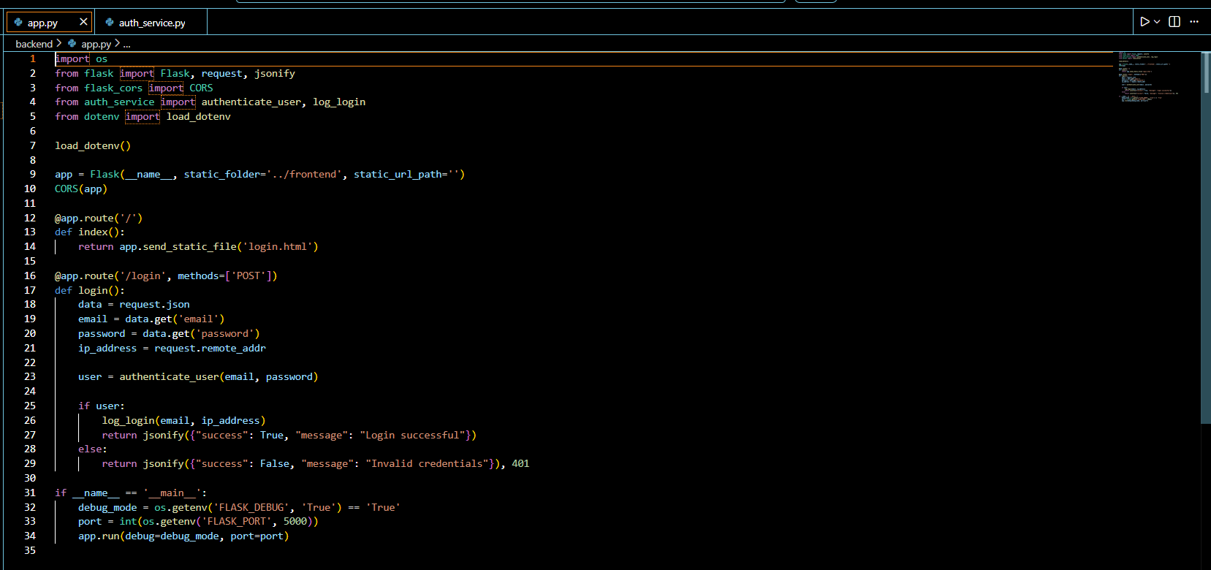
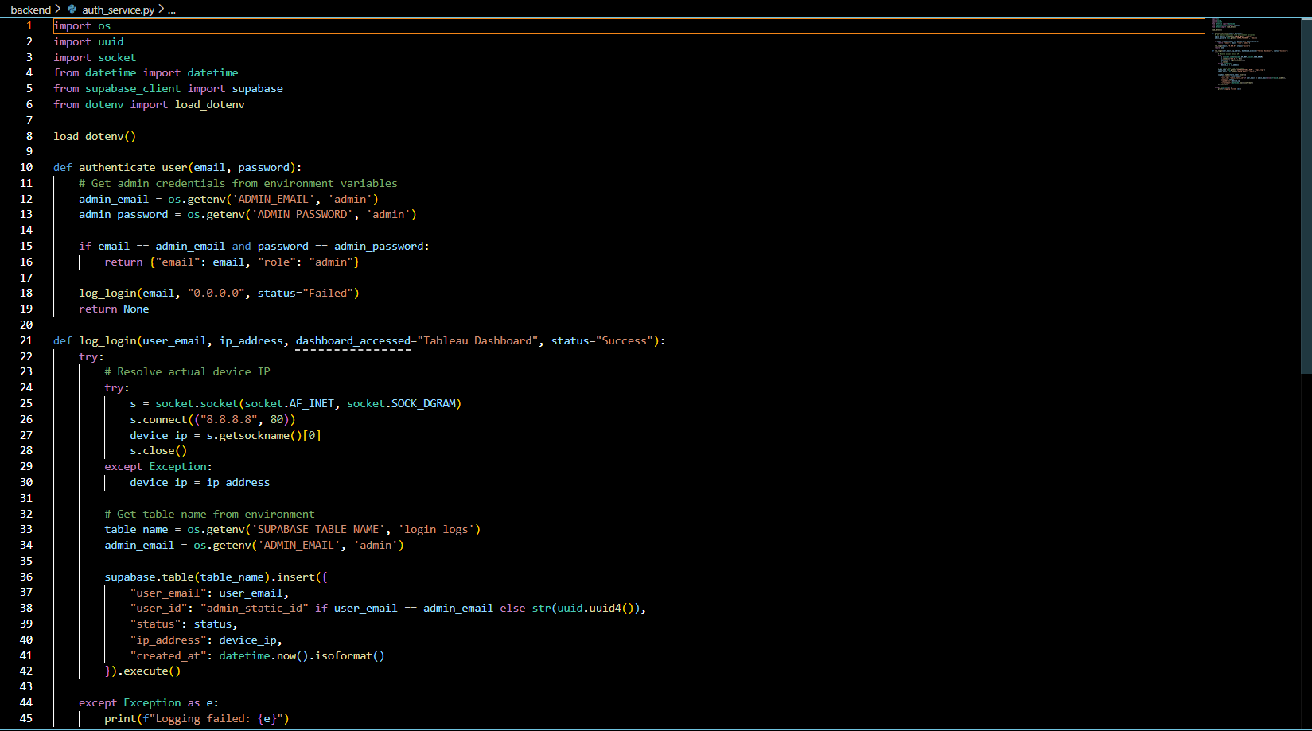
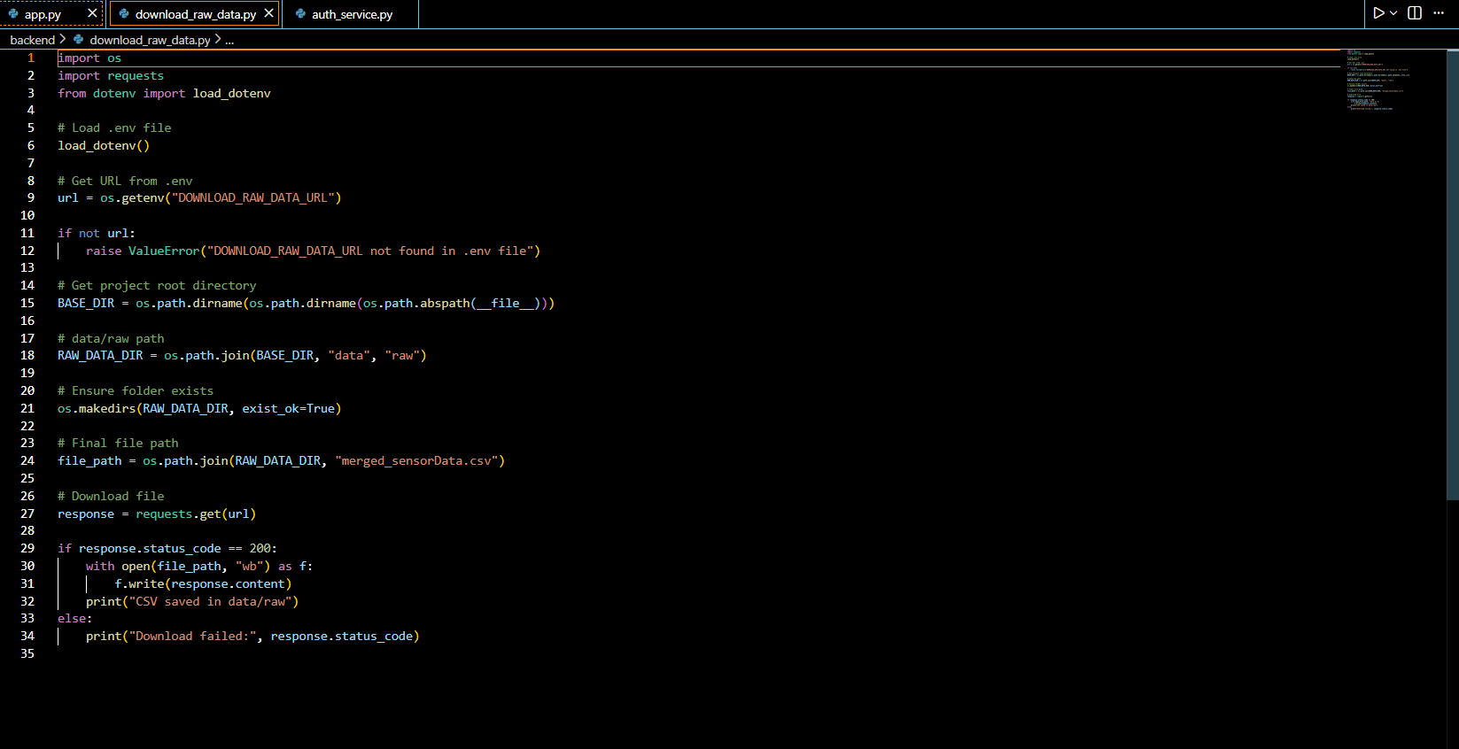
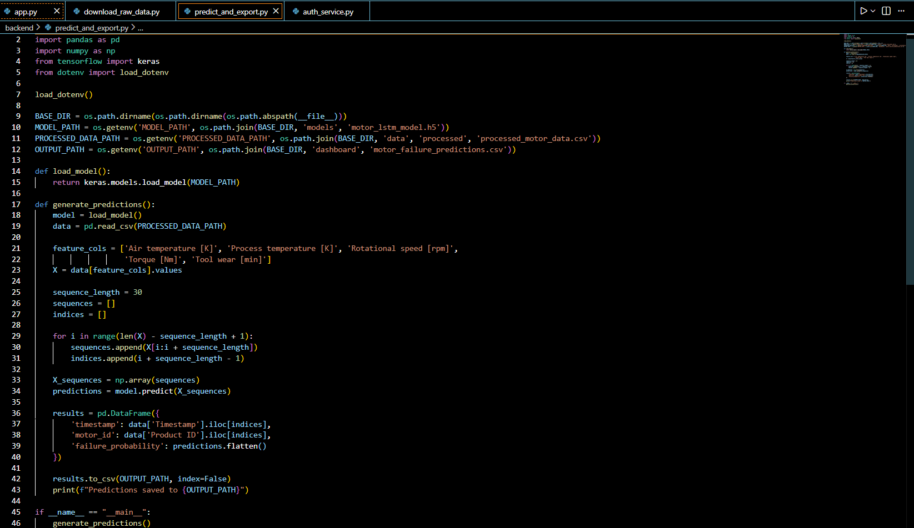
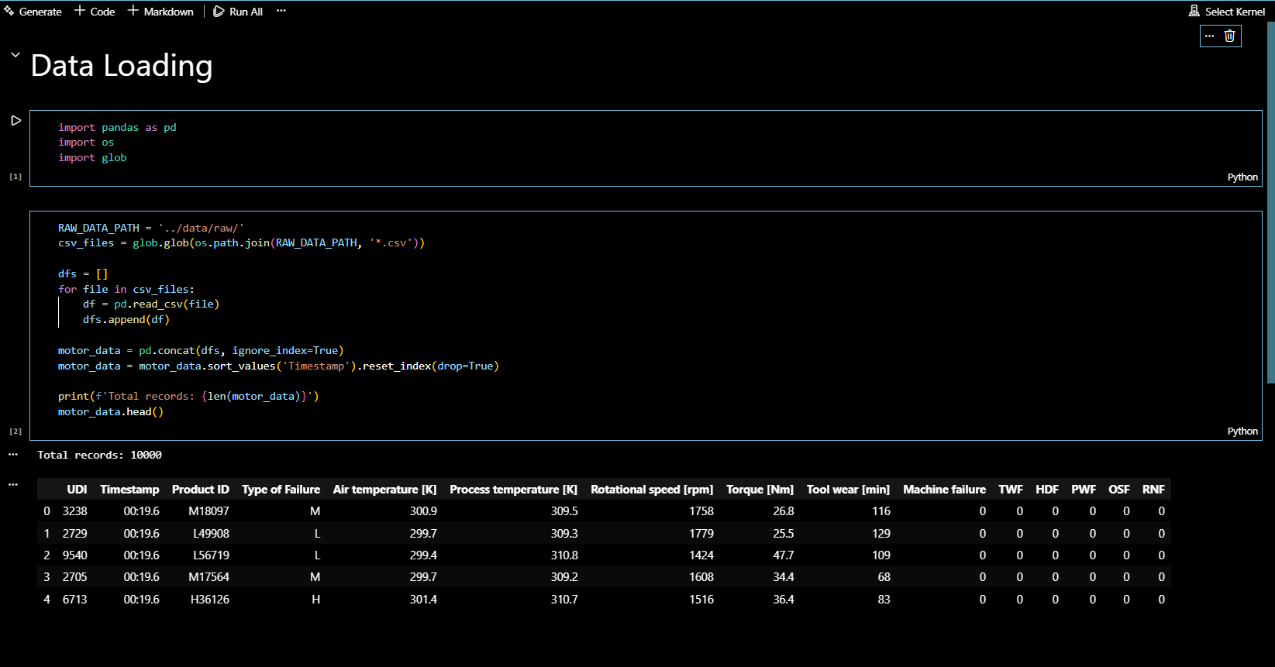
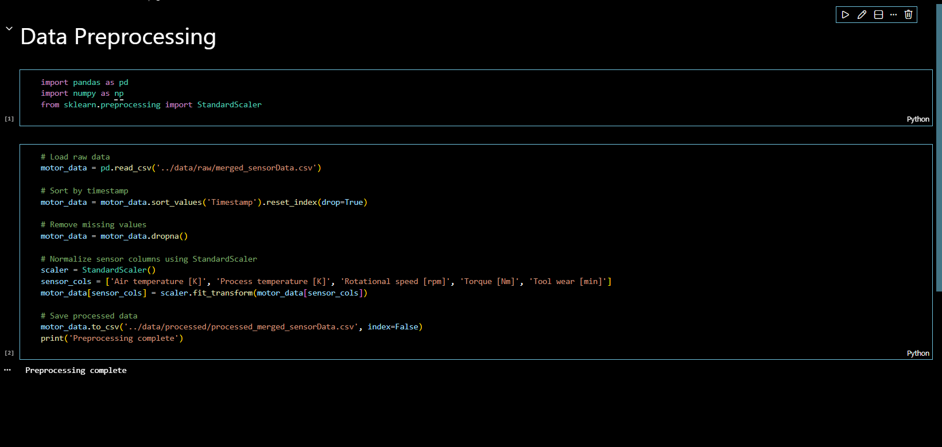
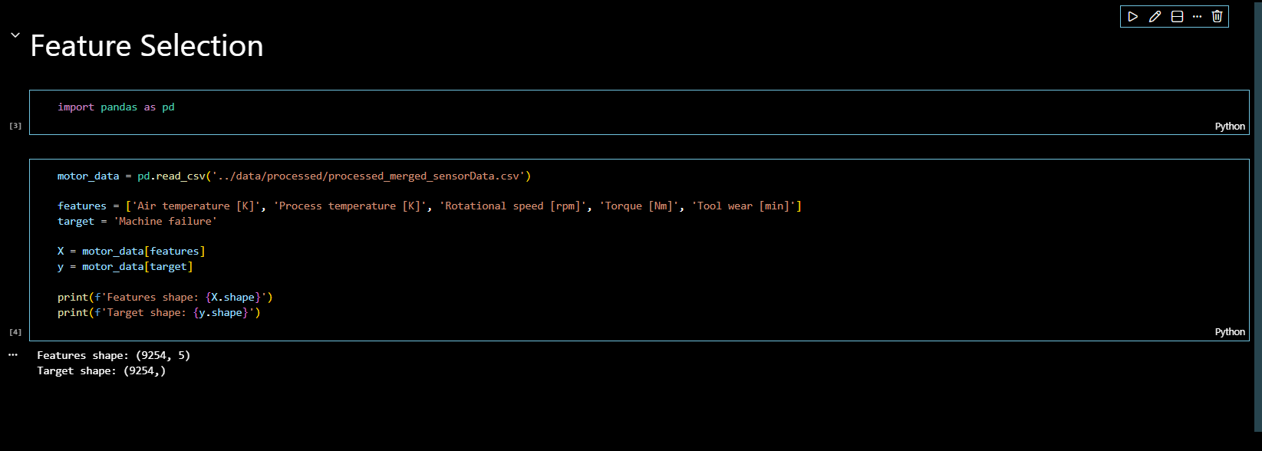
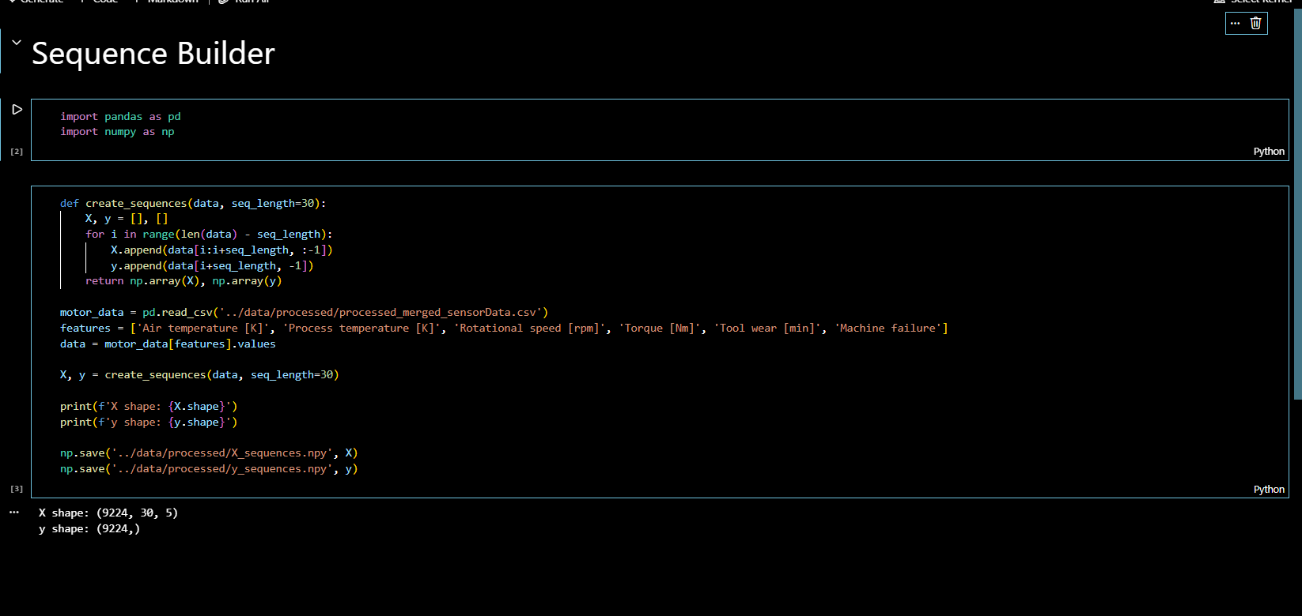
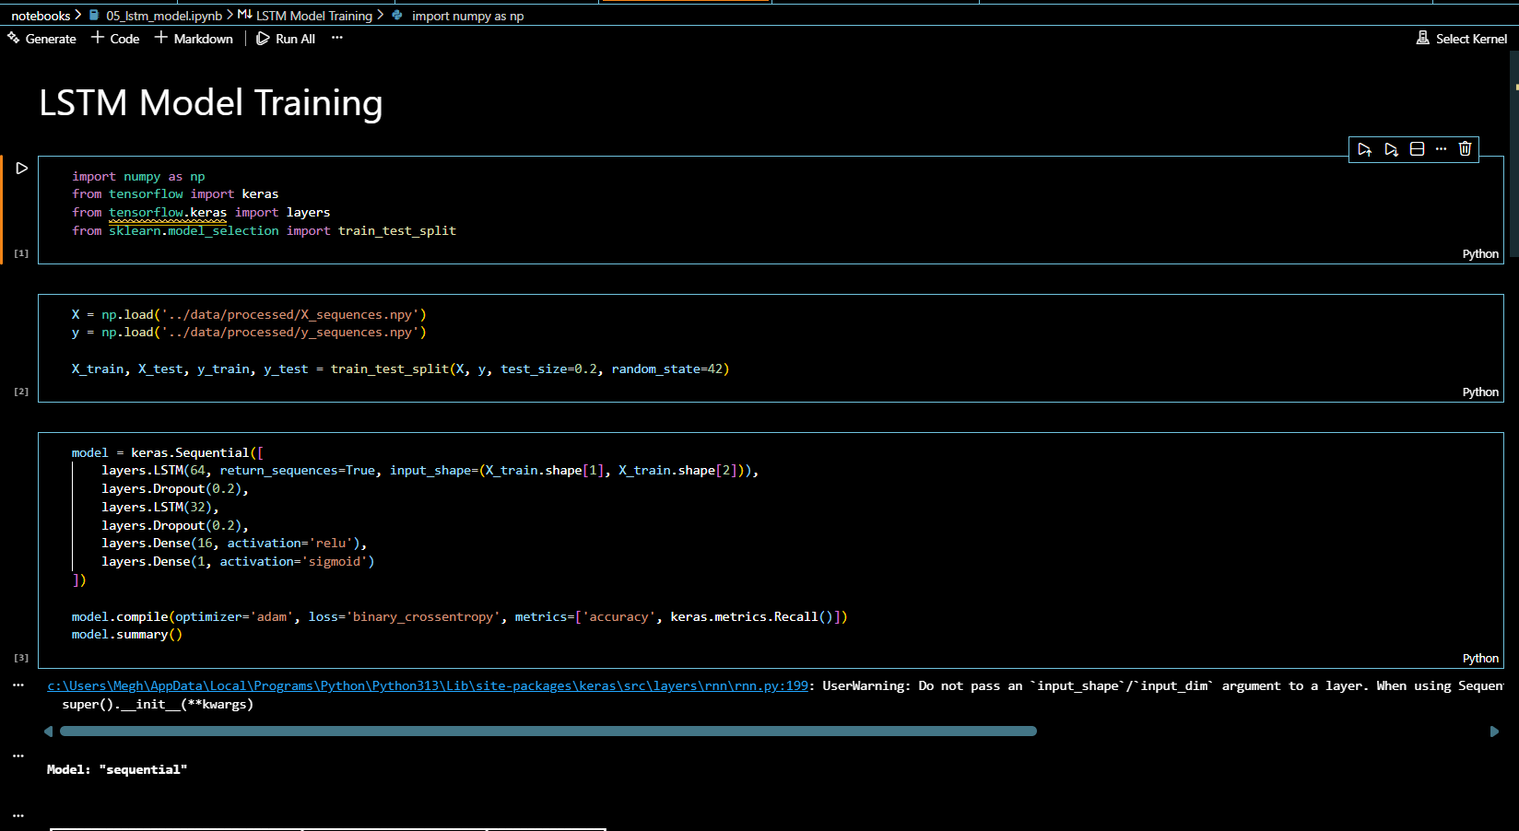
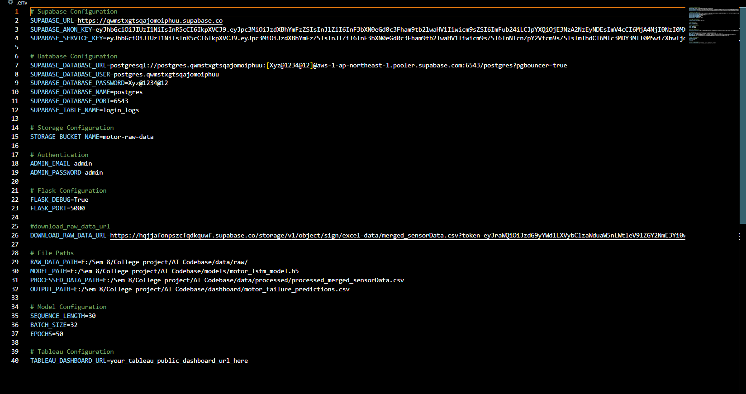
Here is a detailed explanation of all code that is in screenshot:
- Backend Application (Flask – app.py)
- The backend of the system is developed using the Flask framework. It initializes the application, enables CORS for frontend-backend communication, and loads environment variables securely using the dotenv library. The application provides a root route that serves the login page and a /login API endpoint that handles user authentication through POST requests. User credentials are validated using a custom authentication service, and login activities are recorded along with the user’s IP address. The backend dynamically reads configuration settings such as port number and debug mode from environment variables to maintain flexibility and security.

- Authentication & Logging Service (auth_service.py)
- The authentication service manages user verification and login logging. Admin credentials are securely retrieved from environment variables. Upon successful authentication, user details including role information are returned. All login attempts (success or failure) are logged into a Supabase database table. The logging mechanism captures user email, IP address, login status, and timestamp. This ensures proper monitoring, traceability, and audit control within the system.

- Data Download Module (download_raw_data.py)
- This module is responsible for downloading raw sensor data from a configured URL stored in the environment file. The script retrieves the dataset using the requests library and stores it in the designated raw data directory. It ensures directory creation if it does not exist and validates the download status before saving the file. This module automates the data acquisition process.

- Data Loading Notebook
- The data loading process reads multiple CSV files from the raw data folder using Pandas. All files are concatenated into a single dataset, sorted by timestamp, and indexed properly. The total number of records is displayed to verify successful data integration. This step prepares the dataset for preprocessing and further analysis.
- Data Preprocessing Notebook
- In this stage, the raw data is cleaned and normalized. Missing values are removed, and sensor-related numerical columns are standardized using StandardScaler from Scikit-learn. The cleaned dataset is then saved into a processed data directory. This ensures consistent scaling and improves model performance during training.

- Sequence Builder Module
- The sequence builder prepares time-series data for LSTM model training. It converts the processed dataset into fixed-length sequences (sequence length = 30). Each sequence contains multiple sensor readings, and corresponding labels are generated. The input sequences (X) and output labels (y) are saved as NumPy arrays. This step transforms tabular data into a format suitable for deep learning.

- Feature Selection Module
- The feature selection step extracts important sensor attributes such as air temperature, process temperature, rotational speed, torque, and tool wear. The target variable is machine failure. Features and labels are separated to structure the dataset for model training and evaluation.

- LSTM Model Training Notebook
- The deep learning model is built using TensorFlow and Keras. A Sequential LSTM architecture is implemented with multiple LSTM layers, dropout layers for regularization, and dense layers for final prediction. The model uses binary cross-entropy loss and the Adam optimizer. The dataset is split into training and testing sets for evaluation. This model predicts machine failure probability based on sequential sensor inputs.

- Prediction & Export Module (predict_and_export.py)
- This module loads the trained LSTM model and processed dataset. It generates predictions for machine failure probability using sequence-based input data. The results, including timestamp, product ID, and predicted probability, are saved into a CSV file. This output file is used for dashboard visualization and reporting.

- Frontend (HTML, CSS, JavaScript)
- The frontend consists of login and dashboard pages. The JavaScript file handles form validation, user input checking, role assignment (admin, analyst, viewer), and communication with the backend login API. The interface ensures proper error handling and user-friendly interaction. CSS is used to provide structured and responsive design.

- Environment Configuration (.env)
- The .env file securely stores configuration details such as Supabase URL, API keys, database credentials, file paths, model parameters, and Flask configuration. Keeping sensitive information in environment variables enhances security and maintainability of the system.

CHAPTER 7: CONCLUSION

- The project “Proactive Equipment Care using Analytics with Cloud – Cloud Integrated Analytics” successfully demonstrates how cloud computing and machine learning can be integrated to build an intelligent predictive maintenance system. The developed solution combines data ingestion, preprocessing, time-series modeling using LSTM, cloud storage integration, and a web-based dashboard to provide an end-to-end equipment monitoring framework.

- Through systematic data preparation, feature engineering, and sequence modeling, the LSTM-based deep learning model was able to predict motor failure probabilities effectively. The system achieves high recall and accuracy, enabling early detection of potential failures 24–48 hours in advance. This proactive approach significantly reduces the risk of unexpected downtime and supports better maintenance planning.

- The integration of Supabase cloud infrastructure ensures secure data storage, authentication, and logging, while the Flask-based backend and interactive dashboard enhance usability and accessibility. The project also demonstrates strong alignment with business objectives such as reducing operational costs, improving equipment lifespan, and enhancing overall system reliability.

CHAPTER 8: REFRENCES

